**Week 16**

*Written by Kaarlo*

This week we had a meeting via Discord with our group and we discussed the state of our project and about what to do next. Our 3D-model is in good shape and we have the circuit model on Tinkercad which we have given a demo to as far as we can so the next step was to focus on a bluetooth module and the coding to visualize the data. We found some good frameworks of coding that we could modify for our project. Aleksanteri had picked up our components from school so we were able to start testing the set.

Here are the components built together by Aleksanteri:

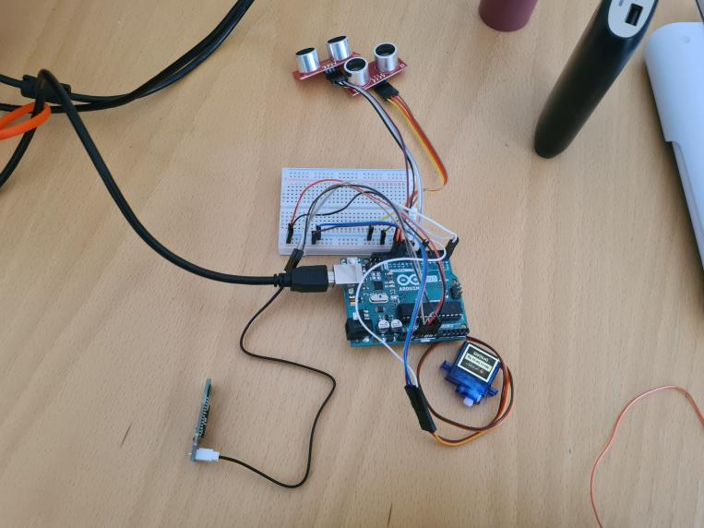

Everything was working except for the bluetooth module which Aleksanteri was working for. However Konsta had his own set of components (with one ultrasonic sensor) and we managed to get data to the computer with it and visualize it on the computer pretty well. Code files will be found in our Drive folder. We were asking about the bluetooth module in TA but Aleksanteri got it working before the session.

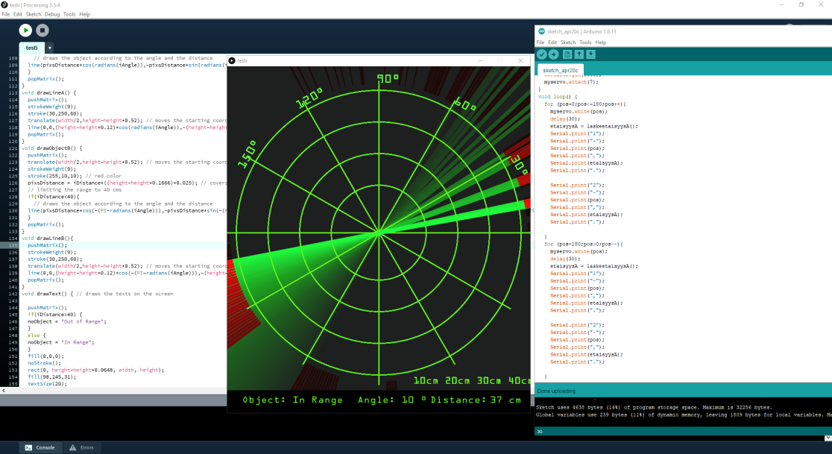

We had a TA-session on wednesday where we showed our progress and asked few things:

* How do we make a reservation to the FabLab?

-We got a link to the reservation page and instructions on how to do it.

* Can we cut our breadboard or could we have a smaller one?

(We don’t need it really much and it would take such a big place in our pyramid box.)

-Supervisor thought that soldering the lines and not using a breadboard would be smart if we don’t need the breadboard a lot.

In the TA-session Aleksi also showed the 3D-model progress and the supervisor approved its printing with minor modifications.

The next step is to finish the 3D-model and reserve the FabLab for printing and soldering. Also we have to decide how to attach sensors to the axle of the servo. Our idea was to get the data to the phone via bluetooth so we have to modify the visualization for the phone as well.

Project team: Aleksanteri, Aleksi, Konsta and Kaarlo